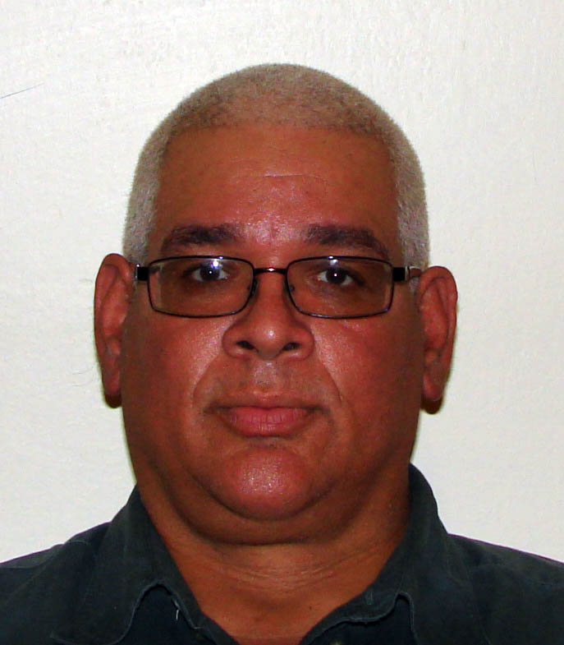 **Carlos Rodriguez**

**30 Blackford Street**

**Cantro Village Santa Cruz**

**Port-of-Spain**

**Trinidad**

**Tel: [H] 868-676-7870 [C] 868-341-3330**

**E-mail: whatscookingcarl@hotmail.com**

**Objective: To be employed with a Company that provides opportunity for growth and**

**Development**

**Work Experience:**

**2013- 2014 TOPPERS SPORTS BAR & GRILL**

**Bartender**

General Management of bar

**2011- Kam WA Restaurant Ltd**

**Bartender & Barista**

General management of bar

**2010-2011 Pier One Ltd**

**Bartender**

Customer Relationship

**1995 - Present Royale Caribbean International**

**Bartender & Barista**

General management of a bar

Customer Relationship

**1992-1993 Electronic Supplies ltd**

Sales Representative

**1990-1991 Professional Security services**

Estate Constable

**Education Institutions: St Gabriel’s Primary / Secondary School**

**Qualifications: Fatima College-1990**

**Computer Corse [Date processing & Basic Programming**

**RISC America-1997**

**Basic Fire & life Familiarization Training**

**RCCI**

**Life Boat & life raft Training**

**Royale Caribbean International**

**Beverage and Barista Training**

**USPH [Food Sanitation, Safety & Microbiology]**

**Warehousing & Inventory**

**References Dominic Sosa**

**Pair One**

**868-631-4541**

**Winston Archer**

**Guardian Life of the Caribbean LTD.**

**Tel: [O] 868-628-9128 [C] 868-678-6571**